**FXP** **Account Activation & Setup User Guide**

Flexential Xperience Portal (FXP)

FXP Account Activation &

Setup User Guide

November 2025

Contents

Introduction 3

Part 1- First-Time FXP Sign-In Experience 3

Activation Email & Set up security methods page in FXP 4

Default Authentication – Email 5

(Optional) Additional MFA Configurations 6

Okta Verify 7

Google Authenticator 8

Phone Authentication 9

Profile Setup Page 10

Select an Organization 11

Dashboard Screen 12

Part 2- Administrator Resources 13

Add New Contact 13

Resend Invitation 15

User Contact Roles 16

Basic Contact Role 17

Part 3: Standard Sign-in Process After MFA Enrollment 17

Initial Sign-in 18

Okta Verify Sign-In Authentication 20

Phone Authentication 21

Google Authenticator 21

Email Authentication 21

Change or Reset Your Password 22

Navigation to My Profile/ Edit My Profile 24

Personal Information 25

Change Password 25

Change Default Organization 26

Notification Preference 26

Flexential Security Pin and Question 27

Reset MFA 27

Flexential Cloud API User Account 28

Expired User Password 29

FAQs 30

Okta-Related FAQs 30

FAQs for Administrator 31

Need Help? 32

Introduction

We are excited to announce an update to the Flexential Xperience Portal (FXP). We have updated the FXP sign-in process with expanded Multi-Factor Authentication (MFA) - powered by Okta - to enable additional security and reliability enhancements.

Before you begin, we recommend you refer to the Okta-Related FAQs and FAQs for Administrators. This Account Activation and Setup user guide contains the following sections:

Part 1- First-Time FXP Sign-In Experience

Part 2- Administrator Resources

Part 3: Normal Sign-in Workflow After MFA Enrollment

Part 1- First-Time FXP Sign-In Experience

Please follow the instructions below to sign in for the first time with the new MFA functionality.

1. **Activation Email for your FXP Account**
   1. **Newly created contacts** will receive the activation email. If you did not receive your email, please contact your administrator.
   2. **Existing contacts** will receive the activation email when they first try to log in. They will need to set up a new password and be prompted to set up their MFA.
2. **Set up security methods**
   1. **Newly created contacts:** Set up a new password.
   2. **Existing contacts**: Set up a new password.
3. **Default Authentication is Email**
   1. Email Authentication is already configured as a default MFA method. If required, configure another MFA method.
4. **FXP Profile Setup page** 
   1. Configure Flexential Security Question and Answer. This page will be skipped for the contacts who have already configured their Security Q & A.

**Note**: You must remember this Flexential Security Question and Answer when you call Flexential Service Support (FSS). An FSS team member will ask you this question to confirm your identity.

1. **Organization Selection Page**
   1. Select the organization, if applicable. (Applicable only to users with multiple organizations)
2. **Dashboard Page**
   1. Once your User profile and MFA have been set up, you will be directed to the Dashboard screen and taken to this screen upon logging into FXP.

## Activation Email & Set up security methods page in FXP

When an Administrative contact creates a new user account, you will receive an email from Flexential (noreply@flexential.com) with your username and the link to complete your account activation. If you are an administrator, see the Add New contact procedure.

|  |  |
| --- | --- |
| 1. Click **Activate Account** in the email to navigate to the Password Setup page. |  |
| 1. Click **Set up** to configure a password for your account. |  |
| 1. On the Set up password page, Enter your password based on the password requirements listed. 2. Re-enter your password. 3. Click **Next.** You will navigate to the multi-factor authenticationset-up page. |  |
|  |  |

## Default Authentication – Email

MFA provides increased sign-in security for users connecting to FXP.

After you complete the password setup, you will be directed to configure Multi-Factor Authentication (MFA).

**Note**: Email Authentication is already configured as a default MFA method.

To proceed with the default Email Authentication method. Click **Continue**.

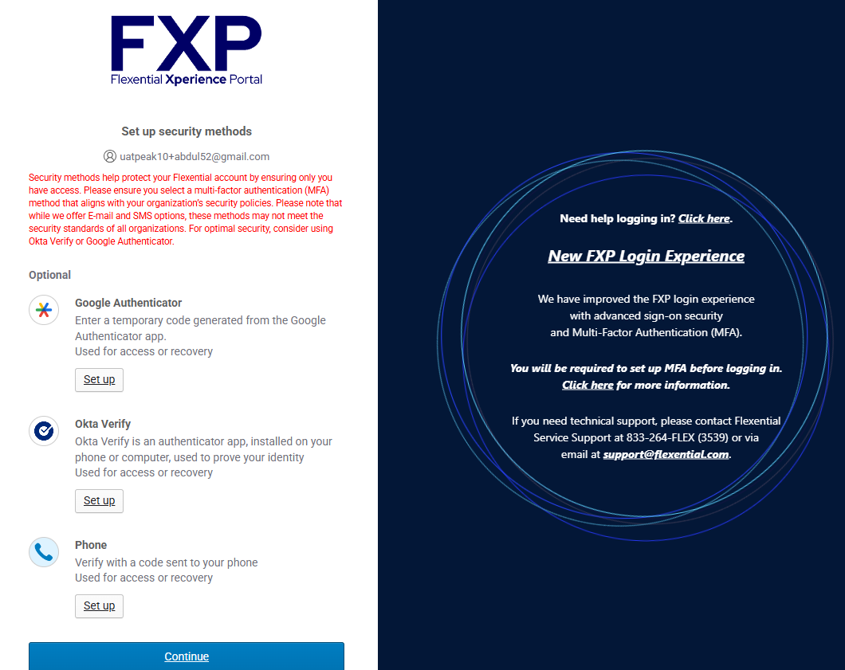

**Tip**: You can configure more than one MFA method if you cannot use a specific method (such as you can't get an SMS Authentication code because you lost your mobile phone).

## (Optional) Additional MFA Configurations

If you wish to add additional MFA, select the following MFAs:

1. **Okta Verify**

* Verify your identity by approving a push notification or entering a one-time code.

1. **Google Authenticator**

* Verify your identity by entering the time-based six-digit code.

1. **Phone Authentication**

Verify identity using a one-time password (OTP) sent to your phone via SMS.

### Okta Verify

To configure the Okta Verify application, do the following:

|  |  |
| --- | --- |
| 1. Click the **Setup** button under Okta Verify. | Badge 1 with solid fill |
| 1. Install the Okta Verify app on your mobile device.   **Example**:  - Download Okta Verify from the [Google Play Store –Okta Verify](https://play.google.com/store/apps/details?id=com.okta.android.auth) and install it on Android devices.  - Download Okta Verify from the [Apple App Store –Okta Verify](https://itunes.apple.com/ca/app/okta-verify/id490179405) and install it on iOS devices.   1. Open Okta Verify on your mobile device and do the following:    1. Click **Add Account** on the Okta Verifyapplication.    2. Select your account type as an **organization**.    3. Click **Skip**.    4. Click **Yes, ready to scan** your QR code.    5. Scan the QR code on the FXP setup screen with your mobile device. (do not scan the QR code shown on this page.)    6. If you wish to enable biometric confirmation, click **Enable**. Otherwise, click **Not now.**    7. Click **Done**. The account-added message appears on your mobile device.   **Note**: If prompted, allow push notifications on your device so that you can approve future sign-in notifications without opening the Okta Verify app. |  |
| 1. If required, configure additional authentication factors. 2. Click **Continue**.   FXP will direct you to the Profile Setup page once you complete the authentication step. |  |

### Google Authenticator

To configure Google Authenticator on your device, do the following:

|  |  |
| --- | --- |
| 1. Click the **Setup** button under Google Authenticator. 2. On your device, download and install Google Authenticator.   **Example**:  - Download [Google Authenticator](https://play.google.com/store/apps/details?id=com.google.android.apps.authenticator2&hl=en_IN&gl=US&pli=1)from the Google Play Store and install it on Android.  - Download [Google Authenticator](https://apps.apple.com/us/app/google-authenticator/id388497605) from the Apple App Store and install it on iOS devices. |**  |
| 1. Launch Google Authenticator on your mobile device and do the following:    1. Click **Add Account** on the Google Authenticator application or click the + sign.    2. Click **Scan a QR code**.    3. Scan the QR code on the FXP setup screen with your mobile device. (do not scan the QR code shown on this page.)    4. Click **Done**. 2. Click **Next.** | Badge 3 with solid fillBadge 4 with solid fill |
| 1. In the **Enter Code** field, enter the setup key shown by Google Authenticator on your mobile device. 2. Click **Verify.** | Badge 6 with solid fillBadge 5 with solid fill |
| 1. If required, configure additional authentication factors. 2. Click **Continue**.   FXP directs you to the Profile Setup Page. |  |

### 

### Phone Authentication

To configure Phone Authentication on your device, do the following:

|  |  |
| --- | --- |
| 1. Clickthe **Setup** button under Phone Authentication. | Badge 1 with solid fill |
| 1. Click the drop-down list and select the country. 2. Type your phone number in the **Phone number** field.    1. Don't include the country code; leave out any dashes and the leading zero if your country's phone system uses them. 3. Click **Receive a Code via SMS**. You receive a code in an SMS message.   The "Send code" button is hidden for SMS authentication. The code will be automatically triggered. | Badge 4 with solid fillBadge 3 with solid fillBadge with solid fill |
| 1. Type the code in the **Enter Code** field. This code will expire in five minutes. 2. Click **Verify**. |  |
| 1. If required, configure additional authentication factors. 2. Click **Continue**.   FXP directs you to the Profile Setup Page. |  |

### 

## Profile Setup Page

After you enroll in the Multi-Factor Authentication method of your choice, FXP directs you to the Profile Setup Page to enter your Personal Information and configure your Flexential Security Question.

On the Profile Setup page, add the following information:

1. In the **Profile Information** section, first name, last name and email address are auto-populated, if required do the following:
   1. (Optional) Add your Mobile Phone number.
   2. (Optional) Add your Business Phone number and its extension.
2. On the **Flexential Security PIN and Question** section, do the following:
   1. Enter your Security PIN in the phone PIN field. The PIN code should be 4 to 6 numerical digits and must not contain a single repeated number or a Simple sequence of numbers. This PIN will be required when contacting Flexential Support by phone.

When you hover your mouse over an icon, a tooltip displays with the Phone PIN instructions.

* 1. (Optional) Type your security question in the Security Question field.
  2. (Optional) Type your answers to your security question.

1. Click **Setup Profile**.

**Note:** After entering all required information (except for optional fields, all fields are required), the **Setup Profile** button becomes active.

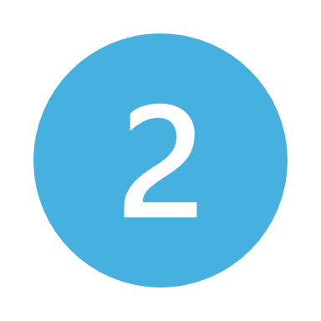

**Note:** Contact with multiple organizations can see the Default organization tile on this page. You can select or change the Default Organization.

## Select an Organization

**Note**: This page applies only to users of multiple organizations.

If you are a member of multiple organizations within FXP, you will be prompted to select an organization name when logging in.

|  |  |
| --- | --- |
| To select a default organization for your user profile,   1. Click on the drop-down menu and select the organization. 2. Click the **Make this my default Organization** check box. 3. Click **Continue**.   **Note**: Once you choose the default organization, you'll be taken to that organization's dashboard the next time you log in.  **Note:** You can change the Default Organization on the Edit Profile Page. See Navigation to My Profile/ Edit My Profile. |**  |

## Dashboard Screen

You can see the Dashboard screen based on your organization's subscriptions and FXP role.

Some widgets and links are unavailable for the users with Basic Role plus Customer Portal access. See Basic Contact Role.

Part 2- Administrator Resources

This section explains the Add New Contact and Resend the Invitation procedures in FXP.

Please refer to the Administration User Guide for Edit Contact, Changelog, and Cloud API User Accounts.

## Add New Contact

To add a new contact, do the following:

1) Under Administration, select the **Add New Contact** option on the top navigation or

2) If you are on the Contact screen, Click the **Add Contact** button.

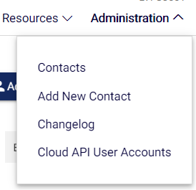

3) On the Add Contact page, enter the Email Address, First Name and Last Name of the person you wish to invite.

|  |  |
| --- | --- |
| 4) Select the appropriate Roles for your new contact.  The available Roles are   * Administrator * Tech Standard * Tech Plus * Billing * Basic   The administrator must assign a minimum of one role to the contact.  **Note**: When users have only the Basic Role for the Customer Portal, they can only see the FXP user guide under Resources. See Basic Contact Role |  |
| 5) Select the Access Permission for your contact. The Available Access permissions are:   * Customer Portal * Flexential Cloud   + Power User   + Read Only   + Standard User   + Tenant Admin * Flexential Disaster Recovery and /or Recovery Cloud * Data Center Access   **Note**: Customer Portal is granted to all users and can't be removed.  If someone is trying to create a user they want minimal access to, they should choose the role of Basic. See Basic Contact Role |  |

6) Click **Submit.** appears on the screen.

## Resend Invitation

To resend the invitation to a contact, do the following:

1. Navigate to the Contacts Page. Select the **Contacts** option under the Administration group in the top navigation.
2. To resend the invitation to an existing contact, click the pencil icon to the right of their name.  
   A screenshot of a computer

   AI-generated content may be incorrect.
3. Under the Access Permission section, click **Resend Invitation**.

**Note**: The Portal Status **Invited** indicates that you have received a notification email but have not yet configured your Okta Initial Setup or MFA.

**Note**: The Portal Status **Active** shows that the contact has successfully logged in and has access to FXP.

1. A message A picture containing font, graphics, screenshot, logo

   Description automatically generated appears on the screen.

## User Contact Roles

An Administrator sets user roles during setup. Multiple roles can be assigned to a single user depending on that individual's needs. The list of available user roles:

1. **Administrator –** Full access to FXP and Support Resources
2. **Tech Standard –** Contact technical support to view technical details of the product/service.
3. **Tech Plus –** Same as Tech Standard above, plus manage products/services in FXP and grant temporary access.
4. **Billing –** Make payments, view invoices, manage billing settings, and contact billing support.
5. **Basic –** Limited views available in FXP. Please see below for additional information on this user role.

|  |  |  |  |  |  |  |  |  |
| --- | --- | --- | --- | --- | --- | --- | --- | --- |
| Understanding Contact Roles & Permissions | | Admin | Tech Plus | Tech Standard | | Billing | Basic | |
| Contact Management | Add and remove contacts | Checkmark with solid fill |  |  |  | | |  |
| Manage contact's roles | Checkmark with solid fill |  |  |  | | |  |
| Manage contact's access to FXP | Checkmark with solid fill |  |  |  | | |  |
| Manage contact's access to the data center | Checkmark with solid fill |  |  |  | | |  |
| Operations | View list of subscribed products/ services | Checkmark with solid fill | Checkmark with solid fill | Checkmark with solid fill | Checkmark with solid fill | | |  |
| Create and manage support tickets | Checkmark with solid fill | Checkmark with solid fill | Checkmark with solid fill |  | | |  |
| Call Flexential Technical Support | Checkmark with solid fill | Checkmark with solid fill | Checkmark with solid fill |  | | |  |
| Manage Support tickets created by others | Checkmark with solid fill |  |  |  | | |  |
| View available product/ service data in FXP | Checkmark with solid fill | Checkmark with solid fill | Checkmark with solid fill |  | | |  |
| Use FXP self-service features | Checkmark with solid fill | Checkmark with solid fill |  |  | | |  |
| Grant Temporary access to the data center | Checkmark with solid fill | Checkmark with solid fill |  |  | | |  |
| Billing | Make Payments | Checkmark with solid fill |  |  | Checkmark with solid fill | | |  |
| View invoices and transactions | Checkmark with solid fill |  |  | Checkmark with solid fill | | |  |
| Download billing-related documents | Checkmark with solid fill |  |  | Checkmark with solid fill | | |  |
| Manage payment methods | Checkmark with solid fill |  |  | Checkmark with solid fill | | |  |
| Manage billing and payment settings documents | Checkmark with solid fill |  |  | Checkmark with solid fill | | |  |
| Contact Flexential Billing Support | Checkmark with solid fill |  |  | Checkmark with solid fill | | |  |
| Purchasing | Order products/services via FXP | Checkmark with solid fill | Checkmark with solid fill |  |  | | |  |
| Order products/services via Phone/email | Checkmark with solid fill |  |  |  | | |  |
| Increase resources/ Quantity to usage based products | Checkmark with solid fill | Checkmark with solid fill | Checkmark with solid fill |  | | |  |
| Profile Management | Manage contact information | Checkmark with solid fill | Checkmark with solid fill | Checkmark with solid fill | Checkmark with solid fill | | | Checkmark with solid fill |
| Manage communication preferences | Checkmark with solid fill | Checkmark with solid fill | Checkmark with solid fill | Checkmark with solid fill | | |  |

## 

## Basic Contact Role

A contact with Portal access and the Basic role assigned can only view some of FXP's screens and modules.

The following sections and screens are available to Customer Portal users with the Basic role.

When a **basic user** logs in, they are **redirected to the Dashboard section**.

* 1. **Dashboard:** Visibility into widgets on the dashboard is restricted for this type of user.
  2. **Solution Suites:** Only the Learn More links are visible to this user.
  3. **Resources tab:** Flexential Documentation and User Guides are accessible in this section.
  4. **Personal Information:** Edit your Profile, Change your password, Answer the Flexential Security Question, and Reset your MFA.

**Note**: For contacts created in FXP with NO portal access before the MFA upgrade, FXP now grants portal access and assigns a Basic role.

**Note**: Contacts will receive a notification when they get access to FXP.

Part 3: Standard Sign-in Process After MFA Enrollment

## Initial Sign-in

To log in, visit <https://portal.flexential.com>/

Your first sign-in information will come from [no-reply@flexential.com](mailto:no-reply@flexential.com). You might want to check your spam or junk box if you don't get an email.

|  |  |
| --- | --- |
| 1. Enter your email address on the Sign In page. 2. Click **Next**. | Badge with solid fillBadge 1 with solid fill |
| 3) Enter your password.  4) Click **Verify**.  **Note:** If you have forgotten your password, then Reset your password. |  |
| 1. When you Sign in for the first time, you must select your default authentication.   You must remember your original MFA method. If you don't know your original MFA method, you can try all four until you are verified using the original method you set up.  Otherwise, you can call Flexential Customer Support to have a Support Representative reset your password.  See Okta Verify, Phone Authentication, Google Authenticator, Email Authentication   1. After you select a default authentication, you will be authenticated using your default method. |  |

|  |  |
| --- | --- |
| Okta Verify Sign-In Authentication | |
| **Get a Push Notification** | **Enter Code** |
| 1. Check your mobile device for a push notification from Okta Verify. 2. Confirm your identity on your mobile device. 3. If prompted, tap **Yes, it's me**, or tap **Review**. The push notification specifies what application you're trying to access. 4. If you enable Push Notification, you can validate the sign-in attempt by tapping **Yes, It's me,** in Okta Verify.   A screenshot of a computer  AI-generated content may be incorrect.   1. If prompted, tap the number that matches what you see in the sign-in window. | 1. Open Okta Verify on your device and remember the verification code on the screen. 2. Enter the code in the sign-in window and click **Verify**.    |

|  |  |
| --- | --- |
| Phone Authentication | Google Authenticator |
| 1. You will receive an SMS to your registered mobile number, and the Sign-In Widget will display the Enter Code field. If you don't receive the code automatically, click Send code.   A screenshot of a phone error  AI-generated content may be incorrect.   1. Type the code provided in the Enter Code field. 2. Click Verify. | 1. In the Enter Code field, enter the key shown in Google Authenticator on your mobile device. 2. Click **Verify.**    |

### Email Authentication

1. Select the Email Authentication. A verification code will be sent to your registered email address.
2. Enter your MFA Verification code.
3. Click **Verify.**A screenshot of a computer

   AI-generated content may be incorrect.

## Change or Reset Your Password

You can change your password for security reasons or reset it if you forget it. To change or reset your password, do the following:

|  |  |
| --- | --- |
| 1. Navigate to [portal.flexential.com](https://portal.flexential.com) and enter your email address. 2. Click **Next.** |  |
| 1. If you have forgotten your password, click **Forgot Password?** |  |
| 1. Select your default MFA and reset your password.   **Note**: You should remember the original MFA method. You can use the **Email Authentication** method if you don't know your original MFAmethod. |  |
| 1. You will receive an email from Flexential with the label of Account Password Reset. 2. Click **Reset Password.** |  |
| 1. This opens a new tab displaying the one-time password reset code. |  |
| 1. Please copy the code and paste it to the login screen. 2. Click **Verify**. |  |
| 1. Enter your new password and repeat your new password. 2. Click **Reset Password**. 3. You will navigate to the FXP Dashboard screen based on your organization and roles. |  |



## Navigation to My Profile/ Edit My Profile

|  |  |
| --- | --- |
| To Navigate to the My Profile page, do the following:   1. Click on your user name (**Example**: Click Demo Contact as per the screenshot.) 2. Click **My Profile** for your profile details. |  |

Editing Your Profile

From the Edit Profile page, you can edit the following information:

* Personal Information
* Change Password
* Change Default Organization
* Notification Preference
* Flexential Security Question
* Reset MFA
* Flexential Cloud API User Account

### Personal Information

|  |  |
| --- | --- |
| If needed, you can modify the following fields in this section:   * 1. Your Email Address   2. First Name   3. Last Name   4. (Optional) Mobile Phone   5. (Optional) Business Phone and Extension   After you update your profile, Click **Submit Changes** to save your changes. |  |

### Change Password

|  |  |
| --- | --- |
| To Change your password, do the following:   1. Enter your **Current Password**. 2. Enter your **New password**.   **Note:** Make sure to set a unique password and satisfy the following password requirements:  Password must not contain the previous four history passwords.   Password must contain upper and lower case letters and a number or symbol.  No parts of your username and at least eight characters long.   1. Repeat your new password in the **Confirm New Password** field.   After you update your profile, Click **Submit Changes** to save your changes. |  |

### Change Default Organization

|  |  |
| --- | --- |
| On the Default Organization section, click on the drop-down list. You will see:   * + 1. None- I want to choose an org for each sign-in.     2. List of all Organizations  1. Select the organization from the drop-down list. 2. (Or) Select **None- I want to choose an org for each sign-in** so that you can select an organization from the Organization Selection page. 3. Click **Submit Changes**.   **Note**: A contact with a single organization does not see the Default Organization section on the My Profile page. |  |

### Notification Preference

|  |  |
| --- | --- |
| **Notification Preferences:** All users have the following notification preference selected by default, except for basic users. If required, clear the check box to remove the Notification.   * **Emergency Notification**   Select the Emergency Notification box to receive an email about potential service and interruptions related to your subscribed services.   * **Maintenance Notification**   Select the Maintenance Notification check box to receive an email about Planned Maintenance activities related to your subscribed services.   * **Survey Notification**   Select the Survey Notification check box to receive an email about the Survey asking about your experience with the Flexential Support team.  **Note:** When you hover over a checkbox, a pop-up screen will display and explain the notification.  After you update your profile, Click **Submit Changes** to save your changes. |  |

### Flexential Security Pin and Question

|  |  |
| --- | --- |
| If you have not updated your security PIN, you will see a pop-up message on the FXP Dashboard after logging in. The message will say, “You do not currently have a PIN code entered.” Clicking "OK" will take you to the section where you can configure your security PIN.   * You can enter your phone PIN using four to six numeric digits. You can only change your PIN once every 24 hours. * You can see and modify your Security Question and Answer from this screen. * This PIN will be required when contacting Flexential Support by phone, replacing the current security question with future updates.   After you update your profile, click **Submit Changes** to save your changes. |  |

### Reset MFA

|  |  |
| --- | --- |
| **Reset MFA:** Users can rest their MFA from this screen.   1. When you click the **Reset MFA** button, the following pop-up message appears:   *"You will be logged out of FXP to reset your multi-factor authentication. FXP sends an email with a link and instructions for the next steps."*   1. Click **Reset MFA** to confirm your action. 2. You'll be logged out of FXP and directed to the FXP Sign-in Page. After signing in, you need to configure any of the MFA methods. 3. (Optional) To configure Okta Verify, Google Authenticator, Phone Authentication 4. To configure Email Authentication, Click **Set up** under email. | Badge 1 with solid fillA white rectangular object with a black border  Description automatically generated  Badge with solid fillA screenshot of a computer error  Description automatically generated  A screenshot of a computer  AI-generated content may be incorrect. |
| 1. You will receive a new email with the one-time password to verify your email address. 2. On the login screen, enter the one-time password you received from your email. 3. Click **Verify**. 4. Click **Continue**. |  |

### Flexential Cloud API User Account

|  |  |
| --- | --- |
| You can reset the API user account or Delete the API key.  After you update your profile, Click **Submit Changes** to save your changes.  **Note**: The Flexential Cloud API User Account section is visible only to the customers with Flexential Cloud on the Contract. |  |

Expired User Password

Your password expires every 90 days. When you sign in to FXP with an expired password and after you enter the MFA token on the MFA authentication page, the expired password screen displays.

To change the password, do the following:

1. Enter the Old password on the Old password field.
2. Enter the New password in the New password field.
3. Enter the new password using the repeat password.
4. Click Change Password.

If your password is about to expire, you will receive emails 14 days before your password expiration. After that, a daily reminder is sent out for 7 days. **Example**: 14 days, then 7, 6, 5, 4, 3, 2, 1 days thereafter.

FAQs

## Okta-Related FAQs

1. **What is Okta?**

Okta provides additional security and reliability enhancements to FXP.

1. **Can my admin see my sign-in information?**

Your organization's administrator can see your username but cannot access your password.

1. **Which browsers does Okta work on?**

Okta supports Internet Explorer, Firefox, Safari, Edge, and Chrome.

1. **What are my username and password for Okta?**

If you don't know your username, contact the Flexential Service Support. If you've forgotten your password, use the Forgot Password link at the bottom of the sign-in page to generate a new one.

1. **Can I be confident that my password is safe?**

Nobody (including the Flexential Service Support) can access your password data.

1. **What if I've forgotten my Okta password?**

If you've forgotten your password, click Forgot Password to reset it on your sign-in page. For additional help, contact the Flexential Service Support.

1. **How long is the Okta activation email valid?**

Seven days. However, the admin can resend the invitation if required.

1. **Do I need to do multiple registrations in OKTA if I am a member of multiple organizations?**

No, FXP sends you only one email to a new user, even if they're associated with multiple billing IDs.

**Note**: Password and Security Questions remain the same for users with multiple organizations.

**9. How can multi-factor authentication methods, such as email and phone authentication, be changed?**

On the My Profile/ Edit My Profile section, click **Reset MFA** to change the MFA methods. You'll be signed out of FXP and directed to the FXP sign-in page. After you sign in, you need to configure a new MFA. See the Configure your Multi-Factor Authentication (MFA).

**10. How do I change my email address ?**

On the My Profile/ Edit My Profile section, update your email address in the Personal Information section. After signing in with a new email address and old password, the FXP takes you to the Setup multi-factor Authentication page.

## FAQs for Administrator

1. **What kind of information can an Administrator change on the Edit Contact Page?**

Refer to the table below.

|  |  |  |
| --- | --- | --- |
| Edit Contact | Edit | Details |
| Personal Information  (Email, First Name, Last Name, and Phone Number) | Badge Cross with solid fill | **View Only**- The Administrator cannot edit or change the personal information of their organization's contact details. |
| Roles | Checkmark with solid fill | The administrator can **edit and change** the Roles of their organization's contact details. |
| Notification Preference | Checkmark with solid fill | The administrator **can edit and change** the Notification Preference of their organization's contact details. |
| Access Permission | Checkmark with solid fill | The administrator **can edit and change** the Roles of their organization's contact details. |
| Flexential Security Question and Answer | Badge Cross with solid fillHidden from the administrator's view. | Administrators can't change the Security Question and Answer for a contact. Only they can change their Security question and answer on the Edit My Profile page. |
| Reset MFA | Badge Cross with solid fillHidden from the administrator's view. | Administrators can't change the MFA for a contact. On the Edit My Profile page, only they can Reset their MFA. |

**Note**: When there are modifications to a contact's Password and MFA, they will receive an email notification.

1. **My contacts had physical data center access but no portal access. Why do those contacts now have portal access?**

* Flexential needs all FXP users, even those only granted data center access via FXP, to set their Flexential secret question/answer for security purposes. You are granted portal access to ensure that you can set your Flexential secret question/answer.
* However, those with only data center access will now only have the BASIC role. Please see Basic Contact Experience in FXP for more info.

1. **How do I add the same contact to more than one organization?**
   1. Sign in to FXP as an administrator.
   2. On the organization selection page, select the organization to which you want to add a new contact.
   3. Enter the existing email address of your contact for the new organization.
   4. Select Roles.
   5. Select Access permission.
   6. Click **Submit.**
   7. Contact can now access the new organization with the existing MFA authentication. Contact does not need to register for a New MFA Authentication.

**Example**: Consider ABC and DEF as an organization, and [xyz@gmail.com](mailto:xyz@gmail.com) is the contact email address.

-Create a new contact, [xyz@gmail.com](mailto:xyz@gmail.com), in ABC Organization.

-Use the same contact email address ([xyz@gmail.com](mailto:xyz@gmail.com)) and create a new contact in the DEF Organization.

The [xyz@gmail.com](mailto:xyz@gmail.com) will receive only one activation email for both organizations. They can select an organization and change the Default Organization.

Need Help?

For questions or additional assistance, please contact Flexential Service Support by opening a new Support Case in FXP via phone at (888) 552-3539 or via email at [support@flexential.com](mailto:support@flexential.com).

**FXP** **Flexential Fabric User Guide**

Flexential Xperience Portal (FXP)

FXP Flexential Fabric User Guide

Contents

Introduction 4

Advantages of mesh interconnection networks 6

Disadvantages of mesh interconnection networks 6

Data Center Interconnect (DCI) 6

Mesh 6

Getting Started – Basic Requirements 7

Order Workflow – Ports vs. Services 7

Media Types and Establishing Link 8

Portal Access 8

Configuration Requirements 8

FXP Portal Access & User Management 9

Admin User Management. 9

Navigate to Flexential Fabric 10

Contact Your Account Manager 10

Flexential Fabric Landing Page 11

Landing Page Map 11

Your Ports & Services 11

Port Level 12

Service Level 13

Order History & Details 14

View Order details 14

Usage Details Graph 15

Manage Usage Notification 16

Update Active Usage Notifications 16

Platform Wide Attributes & Concepts 17

Bandwidth Types 17

Fixed Bandwidth 17

Burstable Bandwidth 17

Considerations when choosing a Bandwidth Type 18

Billing Terms 18

Month to Month 18

Termed (Match to Port Contract) 19

Add Service 20

Navigate to Add Service 20

Add Service: IP Bandwidth - Standard (Static) Connection 20

To add IP Bandwidth, complete the following steps: 21

Add Service: IP Bandwidth FHRP Configuration 25

Add Service DCI 27

Step 2: Review & Submit Order 29

Step 3: Order Confirmation 30

Download Receipt 30

Edit Service 31

Edit Service- IP Bandwidth- Standard/ FHRP 32

Edit Service – DCI 34

Delete the IP Bandwidth Service (All Connection Types) and DCI 34

Need Help? 35

Appendix – A: Advanced Concepts & Technical Insights 36

Bandwidth Partitioning & Allocation 36

IPv4 vs IPv6 37

SLA (Service Level Agreement) 37

Overages and 95th Percentile Calculations 37

WAN Transit Assignment 37

Appendix – B: Additional IP Bandwidth Connection Configurations 38

Add Service: IP Bandwidth BGP Configuration 38

Edit Service- IP Bandwidth- BGP 40

Glossary 41

Roles and Responsibilities Matrix 41

Introduction

Flexential Fabric is a virtual interconnection service available on demand that enables you to establish direct, secure, and dynamic connections to various interconnection services and ecosystem destinations on the FlexAnywhere platform. Specifically, Flexential Fabric is a software-defined service where multiple virtual circuits (VCs) can be turned up or down with a few clicks of a mouse. Connections can be made, monitored, and changed on our self-service Flexential Xperience Portal (FXP).

* FXP is optimized for easy interconnect assembly in minutes from anywhere in a diversified provider environment.
* Flexential Fabric enables enterprises to dynamically scale connections to meet demand, making them more agile.
* Full control and choice over your contract terms and bandwidth allocations give you a competitive edge.
* Flexential Fabric is the next step in an enterprise's digital transformation journey by facilitating faster and more efficient connectivity to their physical or virtual infrastructure distribution.

The Flexential Fabric will regularly add new networking products, services, ecosystem destinations, and partners. As of this release, the following **FXP Fabric-supported services**:

* IP Bandwidth (IP Transit)
* Data Center Interconnect – DCI (Private Transport)
* Mesh (Interconnection Mesh)

The Flexential Fabric is delivered via 10Gbps Single-mode Fiber interface(s). Once a single or multiple physical interface(s) are ordered and installed, all user's self-service functions, including adding, changing, and deleting services, are available in the FXPportal.

Interconnection services are segmented on physical port(s) using standard 802.1q VLAN trunking, enabling multiple layers of two virtual connections to be activated on a single port. Bandwidth commit speeds are available from 10 Mbps to 10,000 Mbps, depending on the service selected. Once active, connections can be scaled based on traffic demands and speed needs.

Bandwidth can be either fixed or burstable on each VC. Additionally, VCs can carry a fixed contract term, or users can opt for month-to-month billing.

In a **mesh interconnection** network, each device in the network sends its own signals and information. Each device or node on the network is connected to the others, and this connection allows information to be relayed across the network from any node without delay or failure.

With Flexential Fabric, users can improve business agility, reduce their time to market, improve scalability, and optimize network costs by:

1. **Deploying** Flexential Fabric ports in strategic metros with large populations of end users and high traffic volumes.
2. **Selecting** the proper services you need via the FXP portal:

* IP Transit
* Private transport between data centers (DCI- Data Center Interconnect)

1. **Connecting** to clouds, infrastructure, networks, and other ecosystem destinations in minutes.

|  |  |
| --- | --- |
|  | Flexential Fabric WorkFlow Cheat Sheet  IP Bandwidth is a Flexential premium, managed, and blended Internet Service.  Data Center Interconnect (DCI) is a Flexential private point-to-point layer two virtual circuit service.  Mesh  Connection Type   * Standard - Standard deploys Flexential internet service on a single interface and virtual circuit with basic static routing. Standard is the default and is recommended for most deployments. * BGP - Border Gateway Protocol (BGP) uses advanced dynamic routing instead of static routing on Flexential Internet service. Customers seeking redundancy would order an additional 'BGP' Service on another physical interface. * FHRP- "First Hop Redundancy Protocol" (FHRP) uses advanced static routing deployment that requires you to set up your Layer-2 network switching at the edge of your network.   Bandwidth Type  **Fixed** - When you choose the Fixed-rate policies, you will have limitations when you exceed the specified limits. For these reasons, Flexential price Fixed Bandwidth policies at a very slight premium over Burstable Bandwidth policies.  **Burstable** -Burstable bandwidth allows for flexible, cost-effective network speed scaling. Burstable bandwidth will enable users to 'burst' above their bandwidth limit to handle traffic fluctuations.  Billing Terms  A **Month to Month (M2M)** term indicates a renewable term of one-month increments, providing greater flexibility.  The **Match to Port Contract** is committed to a duration matching the port contract.  *Users with Administrator and Tech Plus roles can manage the service. See FXP Portal Access & User Management |

### Advantages of mesh interconnection networks

* Increased scalability
* Enhanced robustness
* Provides more security and privacy protection
* Fastest paths and effective load balancing of information in the network
* Every connection can carry its own data load
* Network redundancy with the best possibility that the network is always available

### Disadvantages of mesh interconnection networks

There are, however, downsides to mesh interconnection networks as well. For example, a common barrier is the noticeable upfront cost required for mesh networks. Key disadvantages include—

* Higher cost
* Greater administrative overhead
* Difficult installation and configuration
* Bulk communication links required to implement

### Data Center Interconnect (DCI)

Manage workloads between data centers with private connectivity between resources distributed across metros

* It builds transparent, layer 2 interconnects between two Flexential data center locations
* It enables connectivity between two locations over the Flexential backbone
* Can be used to share resources, data, or workloads
* DCI is not recommended for multi-site connectivity, it is strictly meant for point-to-point connection types

### Mesh

A flexible layer 2 or layer 3 mesh network to interconnect data centers across the Flexential backbone.

* Designed for customers connecting three more Flexential locations or looking for redundancy between two sites
* Both a layer 2 (E-LAN) and a layer 3 (L3 VPN) option are available Layer 3 option is the preferred connectivity to CDP resources
* Adding additional sites to a mesh network becomes seamless

|  |  |
| --- | --- |
|  | Benefits of the Flexential Fabric:   * Improved access and centralized control through a self-service web portal in FXP. * Self-driven provisioning for on-demand access and optimal service delivery. * Rapid deployment and faster time to market with automated circuit provisioning. * Software-defined interconnection that directly connects to Flexential IP Transit and Private Transport services. * Lower costs for ports and cross-connects by combining physical ports and VLAN segmentation. * Automated provisioning that reduces dependency on human intervention.   Multiple private and public connectivity options |

Getting Started – Basic Requirements

Before beginning your deployment on Flexential Fabric, you are requested to meet the basic requirements and understand the basic workflow.

## Order Workflow – Ports vs. Services

You can order a physical port by calling FXP Support. This order has been quoted and delivered via an FXP sales representative. Standard provisioning timelines apply. Ordering the physical Port through FXP is not possible.

Once the port order is complete, you will see the port populated in the FXP Portal. All logical service adds, changes, and deletions can be performed directly in the FXP Portal.

**Note:** The content of this User Guide and the ability to order services, assuming that you have ordered and installed physical Flexential Fabric. If you are looking to order or provision services and do not yet have a port.  
Please reach out to Flexential Service Support by opening a new Support Case in FXP via phone at (888) 552-3539 or via email at support@flexential.com.

## Media Types and Establishing Link

**The Flexential Fabric only supports Single-mode Fiber (1310nm) at 10Gbps (10G-LR).** No other media types or speeds are supported at this time. It would be best if you supplied their Optics/SFPs.

Once the physical port has been delivered to your cabinet or cage panel, you must patch this connection to your equipment.   
Layer-2 Link Status should be established before commencing services

## Portal Access

Flexential Fabric services are administrated entirely via the FXP Portal, so proper access should be confirmed. In addition, only portal users with Admin or Tech Plus roles can add, edit, and delete services. See FXP Portal Access & User Management

## Configuration Requirements

The configuration requirements vary widely by service, but at the highest levels, the following configuration requirements should be understood:

* **VLAN (802.1q):** Each service on a Flexential Fabric interface must be delivered with a VLAN tag or header. Services cannot be delivered as untagged or accessed.
* **Border Gateway Protocol (BGP):** Many services on the Flexential Fabric either offer or even require BGP as the routing protocol. If this is your desired protocol, ensure your edge device supports this type of routing and that your team has the necessary knowledge and skills to deploy it.

## FXP Portal Access & User Management

During the initial provisioning process, the Flexential Provisioning team will establish or confirm at least one account administrator for a new port or colocation. If your account loses administrator access or cannot identify who in the organization holds this role, please contact Flexential Support Services (FSS).

Once access is confirmed, user administrators are expected to manage their users. The below section describes the user roles and privileges.

|  |  |  |  |
| --- | --- | --- | --- |
| User Role | View Service Order and Status | Create/Change/Delete Service | Manage Users |
| Administrator | Yes | Yes | Yes |
| Tech Plus | Yes | Yes | No |
| Tech Standard | Yes | No | No |
| Billing | Yes | No | No |
| Basic | No | No | No |

## Admin User Management.

The admin role is a critical responsibility for managing user access and permissions, and this should be one of the first tasks IT administrators perform when first joining the FXP platform. Because Flexential Fabric is built within FXP, many existing FXP users will have users properly established and be familiar with the interface, but we suggest confirming the following for each of your users,

1. Do you have the right users? Does anyone need to be added or deleted?
2. Do the right users have portal access enabled?
3. Are the correct roles set for each user?

To navigate to View Contacts, select Administration from your top navigation and click **Contacts**.

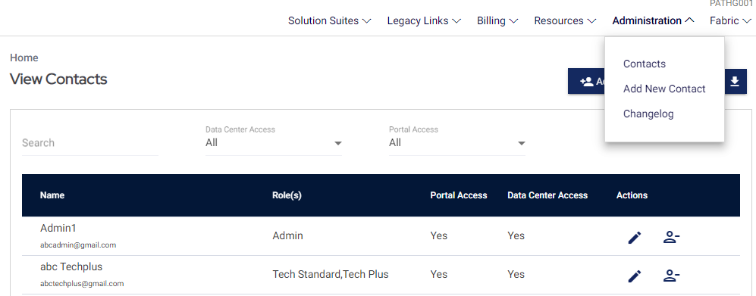

# Navigate to Flexential Fabric

After you log in to FXP, the Fabric menu will appear at the top of the navigation. On the Fabric menu, you can do the following:

|  |  |
| --- | --- |
| 1. Click **Fabric** to open the **Fabric** Landing page. 2. Click Contact Your Account Manager to view contact details. 3. Click **Add Service** to add IP bandwidth or DCI services for your port. 4. Click **Order History** to view the existing orders and their status. | Badge with solid fillBadge 1 with solid fillBadge 3 with solid fillBadge 4 with solid fill |

# Contact Your Account Manager

Click the **Contact Your Account Manager** link to open a pop-up screen displaying the details of the Account Manager and Customer Success Manager email and phone number. Also, use the **Support Center** link to create a support ticket.

# Flexential Fabric Landing Page

Flexential Fabric landing opens with **Your Ports & Services** and **Order History & Details**tabs, each with further information and widgets.

## Landing Page Map

A dot on the landing page map displays the map for each data center where a user has services. When the user hovers over a dot, a field displays the total number of active and pending services.

|  |  |
| --- | --- |
| 1. One text box field per data center 2. No. of Active Service(s) 3. No. of Pending Service(s)   The map displays the entire United States mainland.  If the user does not have any services, then the screen displays an empty map with no dots. |  |

## Your Ports & Services

Your Ports & Services provides a further hierarchical overview with critical information and visibility, as well as direct links and options to change your services on demand. Conceptually, it is best to understand this visibility in two tiers:

1. Port Level
2. Service Level

Specific services are provisioned to specific physical ports. This overview approach allows you to visualize which services reside in which ports and locations easily.

## Port Level

1. The **Port Naming Convention** provides you with important information about the physical port. Using **uesw001.den03-10G-**PID100001 as our example,
   1. **uesw### (e.g., uesw001)** –This identifier counts the switch number in the respective location. Switch numbers are important to implement redundancy. For redundancy ports, details of 001 and 002 switches are helpful.
   2. **LOC## (e.g., DEN03)** – This identifier is used for a specific location, including a city and data hall. It is important to note that this is the location where the Flexential Fabric switch physically resides, meaning some of you have your colocation in an adjacent data hall, not the exact data hall.
   3. **##G (e.g., 10G) –** This identifier confirms the physical interface speed. Currently, only 10Gbps/10G-LR is supported.
   4. **PID###### (e.g., PID100001) –** The PID is a Port Identifier that is unique identifier. This allows for easy communications with the Flexential Support Team when issues arise and also supports Flexential operational work like migrations or changes such that users are not impacted, for example, during an RMA or switch port change.
2. The Bandwidth Allocation and Utilization tools provide critical insight into the physical port,
   1. **## Gbps Provisioned –** This metric adds all committed rates of services on your port. Flexential recommends that you do NOT oversubscribe ports; extra care is taken with burstable services. See Bandwidth Partitioning & Allocation
   2. **Port Usage –** The **Port Usage** button helps you to view the utilization of the physical port, which means all services combined for this port, not just a specific service. See Usage Details Graph.
3. The **status** includes,
   1. **Port Connectivity –** This metric is equivalent to Ethernet Link status. It is a simple Up or Down output, visually represented as 'Up' = Green and 'Down' = Red.
   2. **Port Light Connectivity**   
      Displays a green check or red X or Unknown grey icon for the Port Light Level with the following conditions:
      1. For Tx power, if the value returned is from -8.2 to 0.5,  a green check mark will display.
      2. A red check will be displayed if the Tx power value returns outside of this range.
      3. For Rx power, if the value being returned is from -14.4 to 0.5, then a green check mark will display.
      4. A red check will be displayed if the Rx power value returns outside of this range.
      5. The unknown grey icon displays for the unknown Port light connectivity.

When a red X status returns, text will display as a user hovers over the X icon.

The verbiage will display the following message: *Flexential is not detecting optical light from your equipment within acceptable thresholds; you may need to check your equipment and roll your TX/RX fibers.*

1. The Services List displays a simple count of **Active** and **Pending** services for quick reference when seeing if a new order has been installed or deleted.
2. The **View Service Details**button expands a new view, covering each unique interface service.
3. The **Add Service**button lets you quickly add a new service using a specific physical port as a reference.

## Service Level

Click **Show Service Details** to expand an in-depth table view of active services on a respective port.

1. **Service** provides a basic indication of which product or service this VC supports.
2. **Service State** and **Order Status** provide feedback on the provisioning process and service status.
3. The **Order ID** field represents the most recent order against a specific service.
4. The **Service ID (SID)** is a unique identifier for a specific logical service that may contain many interfaces; for example,
   1. A DCI contains two interfaces, a point-to-point service with an A and Z side. The SID for both interfaces is the same, as they are part of the same DCI.
5. The **Service Description** lets you add a friendly name or alias for the service or operations. For example, "Prod Internet" or "Backup DCI."
6. In contrast to the SID, the **Unique Circuit Hand-off ID (VID)** is the most discrete and specific identifier in the hierarchy and represents a particular interface for a specific service,
   1. e.g., the SID represents all interfaces in the DCI; the VID represents just the A side or Z side
7. **Commit** is the committed contract quantity.
8. **Overage Warning Indicator**: When the Burstable Port bandwidth usage exceeds the 95th percentile, this red alert is displayed on the Service Details page. It alerts the users about the potential overage charges.
9. **Rate Limit** is the maximum allowable limit of what you can consume if they are on a burstable service.
10. **Term Ends** reflects whether a service is Month-to-Month or Match to Port Contract.
11. The **Actions** icons offer several direct links. The user with Administrator and Tech Plus roles can see the following links:
    1. Click the **bar graph icon to view** the**Usage Details Graph**for this specific service on this specific interface (i.e., VID), in contrast to the above utilization chart that showed the entire physical interface.
    2. Click the **pencil icon** to Edit the service.
    3. Click the **trash icon** to Delete the service.
    4. Click the eyeball icon to View the installed service details and most recent **Order Details, w**here you can get further information about your service not represented in this table.

**Note:** Under the Actions sections, the eyeball icon (View), pencil icon (Edit), and trash icon (Delete) are not displayed for Tech Standard and Billing role users.

# Order History & Details

To navigate to **Order History and Details**, do the following

1. On the top navigation, select **Fabric** and then choose **Order History**.
2. On the Flexential Fabric landing page, select Order History & Details.

|  |  |
| --- | --- |
| Badge 1 with solid fill |  |

The Order History & Details page opens and displays the order details. Refer to the Service Level section to see the details for each column.

Term Ends is a column that displays the end date of service. For Month-to-Month subscriptions, the format of the Term Ends displays in MM/DD/YYYY. For Termed contract users, Match to Port Contract text is displayed.

## View Order details

Under the Actions section, click the eye icon to view the order details.

1. **View the Order details**: This shows the order details of your Flexential Fabric.
2. **Order Price details**: Shows the Setup Price Total, Monthly Price Total, and Contract Term Total.
3. **Download order history**: Click the Download order history link to download order details in the pdf version.
4. **Contact Support Center:** Click the Support Center to contact the Flexential support team.

 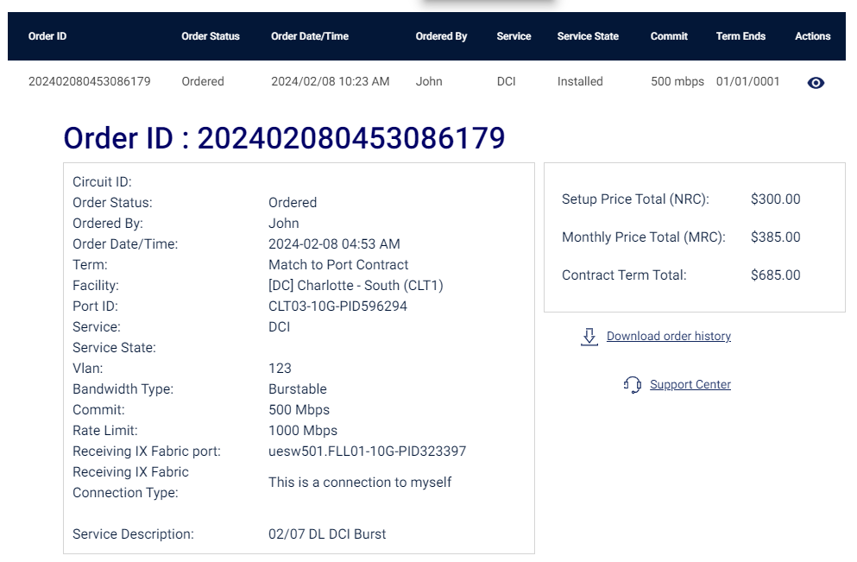

# Usage Details Graph

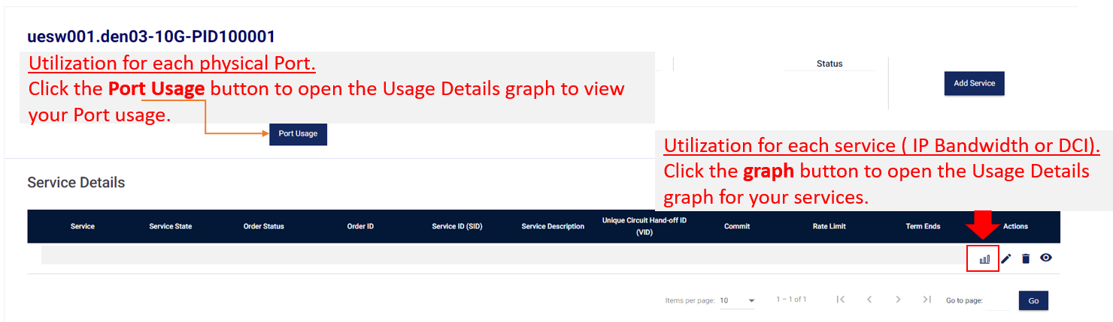

The Usage Details graph displays your utilization graph.

1. Click the In and Out buttons to toggle between usage types
2. Select from the data center location drop-down to view port-level usage for that location (if you have access to multiple DC sites).
3. Filter the graph by clicking one of the period buttons or by dragging the slider at the bottom.
4. Click to hide/show graph legends on the left of the graph, and click locations in the legend to toggle them on/off in the chart view.
5. Click **Set Notification** to open the pop-up for managing usage notifications.
6. Shows 95th percentile for port usage and usage details

## Manage Usage Notification

|  |  |
| --- | --- |
| On the Manage Usage Notification pop-up screen, do the following:   1. Enter an **Alert Threshold** value. A notification is sent to the alert recipients when the threshold matches your input value. 2. Select an **Alert Interval**. It specifies the frequency of email notifications when the Alert Threshold is satisfied. One may establish intervals of three, six, or twelve hours. 3. Define **Alert Recipient(s)** by entering email addresses in this field. Press ENTER on your keyboard after each email address to enter multiple recipients. 4. Click the **Add Usage Notification** button when finished with setup to create a usage notification. 5. Click the **Cancel** button at any time to close the notifications page without saving the usage notification. |  |

Update Active Usage Notifications

After you add a notification, you can update the usage notifications. Click Set notification on the graph to open the pop-up screen.

1. Select the location with activie usage notifictions from the **Data Center** dropdown
2. Edit the **Alert Threshold** value, **Alert Interval**, and/or **Alert Recipient(s)** fields
3. Click the **Update Usage Notification** button to save changes
4. Click the **Delete Usage Notification** button to remove the existing notification
5. Click the **Cancel** button at any time to close the notifications page without making/saving changes

# Platform Wide Attributes & Concepts

## Bandwidth Types

When you order interconnection services (IP Bandwith, DCI), you will have the option to select one of the following policies for your virtual connection:

* Fixed
* Burstable

Fixed Bandwidth

A fixed bandwidth policy will limit the maximum bandwidth throughput of the virtual connection to the value selected in the field titled "Choose a Commit". The amount of bandwidth selected in the "Choose a Commit" field is a guaranteed amount that is always available to the user. Please note that the field titled "Choose a Rate Limit" is unselectable due to the fixed option being selected for bandwidth type.

Burstable Bandwidth

A burstable policy enables the virtual connection to have additional bandwidth if traffic spikes beyond the committed rate. A rate limit can be selected if the user wishes to burst past the committed bandwidth amount but not to the full port size of 10,000 Mbps. **Please note that the rate limit must have a value greater than the committed amount and less than 10,000 Mbps in increments of 1,000 Mbps**. Whether fixed or burstable, the bandwidth is a guaranteed amount that is always available to the user. Please see the example of a burstable bandwidth connection type with a commit of 1,000 Mbps and a rate limit of 5,000 Mbps. Overage charges are determined by using the standard 95% calculation. They are charged at the same rate as the committed bandwidth without any overage penalty.

Please note, even with rate limits implemented, traffic could spike beyond the designated upper limit as this depends on many factors, such as the OEM, configuration of the policer, and the traffic profile. Users will not be charged if traffic exceeds the rate limit, as this measure is predominantly for financial protection.

Considerations when choosing a Bandwidth Type

If a user wants to eliminate the possibility of any overage charges and is comfortable with traffic loss during any saturation event, the fixed bandwidth policy is the most technically conservative approach. On the other hand, if a user desires to compensate for traffic demand during increased spikes, a burstable policy should be selected to create the most flexible and optimal network solution. A rate limit can be implemented for specific traffic thresholds that do not want to be breached while satisfying limited traffic overage demands. Rate limits provide good stop-gap measures for partitioning multiple virtual connections on the same physical interface for uniform bandwidth allocation and financial overage protection for limited bursting.

Please see the use cases between fixed and burstable bandwidth options:

|  |  |
| --- | --- |
| **Burstable Bandwidth** | **Fixed Bandwidth** |
| Greater Speeds in Times of Demand and Peak | Constant bandwidth irrespective of usage. |
| Minimal latency for quicker data transfer | Unexpected decrease in Internet speed. |
| Improved performance of the network and apps | Good performance of the network and apps |
| Scales without changing your term or service plan | Does not take usage fluctuations into account. |

Finally, toggling between fixed and burstable bandwidth types on the same virtual connection is not supported by Flexential.

Billing Terms

Once a user decides on their bandwidth policy type, they will then be prompted to select between the following options for billing terms:

* Month to Month
* Termed (Match to Port Contract)

Month to Month

A Month to Month (M2M) term indicates a renewable term of one-month increments, providing greater flexibility. An M2M connection is ideal for ad hoc or temporary business projects requiring temporary connectivity, not production workloads. Please note that M2M only applies to the layer two virtual connections and does not apply to the physical interface.

Termed (Match to Port Contract)

The Match to Port Contract is committed to a duration matching the port contract. Please note that the contract with Flexential must have at least 12 months remaining. Once this option is selected, the connection will be added to the respective contract. Match-to-Port Contract connections are optimal for production workloads that must remain in place without interruption. Please note that terms can be increased but not decreased.

Month-to-Month and Match-to-Port Contract options can be selected for Fixed or Burstable bandwidth types.

However, toggling between Month-to-Month and Match-to-Port Contract is not supported by Flexential.

Add Service

The following sections provide instructions for each specific product, service, or destination on Flexential Fabric. These sections capture the basic, default, or recommended approaches.

Add Service: IP Bandwidth - Standard (Static) Connection

Add Service: IP Bandwidth BGP Configuration

Add Service: IP Bandwidth FHRP Configuration

Add Services DCI

## Navigate to Add Service

To navigate to the Add Service page, follow any one of the below methods:

|  |  |
| --- | --- |
| 1. On the top navigation, choose **Fabric** and then click **ADD SERVICE.**    | 1. (Alternatively) On the Fabric landing page, under Your Ports & Services section, click the **Add Service** button.    |

1. Click the **Order Now** button at the bottom of the Fabric Landing page. Clicking on this button opens with a prefilled selection for IP Bandwidth and DCI.

## Add Service: IP Bandwidth - Standard (Static) Connection

IP Bandwidth is a blended solution that supplies users with scalable and quickly provisioned IP transit access. This service utilizes multiple tier-one internet providers to deliver high availability, reliability, and speed.

Please note that the Standard (static) configuration is Flexential's recommended default configuration type. The standard configuration provides a single virtual circuit with static routing. Please reference the appendix section for special considerations regarding adding a BGP or FHRP configuration for IP bandwidth. Please reference the following architecture for the Standard configuration below:

**Before you begin:** To add a service, you are required to satisfy the following conditions:

1. You must have at least **one active** port provisioned in FXP. See How to order a port.

2. Administrator or Tech Plus users can Add a Service for your port. See User Roles inFXP Fabric

3. For the FHRP connection type, you need to have a minimum of two Ports in the same data center provisioned in FXP.

4. For the BGP Connection type, advanced routing knowledge is required to configure your equipment.

5. To understand the technical terms used in the Add Service Page, see Technical Terms used in Fabric.

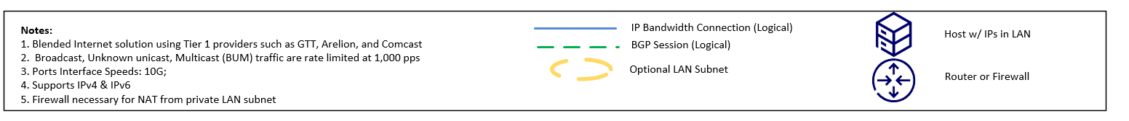

## To add IP Bandwidth, complete the following steps:

|  |  |  |  |  |  |
| --- | --- | --- | --- | --- | --- |
| 1. Choose one of your subscribed ports on the **Select a Port** drop-down menu. | | | | Badge 1 with solid fill | |
| 1. In the **Choose a Service to Add** field, select the IP Bandwidth. 2. In the **Choose a Connection Type** field, select the following configuration type:  * Standard     **Important Note About Redundancy for Standard Connections:**     * If an SLA of 100% is to be achieved, a user should deploy two physical interfaces and configure a single standard connection on each device. | | | |**  | |
| 1. In the **Choose a Bandwidth Type,** select Fixed or Burstable.  * Fixed bandwidth does not allow bandwidth consumption beyond the committed bandwidth value. * Burstable bandwidth allows for overages using the 95% calculation. * Please refer to the Platform Wide Attributes & Concepts section for further details. | | | | Badge 4 with solid fill | |
| 1. In the **"Choose a Commit"** drop-down menu, you can enter or choose the value based on your bandwidth selection.      * **Fixed Bandwidth Type**: Select the Commit Value from the drop-down menu. The values are available from 1000 Mbps to 10,000 Mbps.    * **Burstable Bandwidth Type**: Enter your Commit value. The acceptable value is between 10 and 10,000. | | | | Fixed:  Badge 5 with solid fill  Burstable:  Badge 5 with solid fill | |
| 1. If **"Burstable"** was selected for the bandwidth type, users can choose a rate limit value in the "**Choose a Rate Limit**" field. If "Fixed" was selected, this field is disabled.   **Note**: When you choose a Commit value, the Rate Limit value gets dynamically populated with the next highest value allowed, greater than the Commit. | | | | Badge 6 with solid fill | |
| 1. In the **"Pick a Term"** drop-down menu, select one of the following options (each is explained in the "Platform Wide Attributes – Bandwidth & Billing" section)  * Match to Port Contract * Month to Month | | | | Badge 7 with solid fill | |
| 1. In the **"Enter your VLAN"** field, type the ID value between 2 and 4094. | | | | Badge 8 with solid fill | |
| 1. In the **WAN Transit Assignment** **(IPv4)** field, select either a /31 (2 addresses) or /30 (4 addresses) subnet that is assigned for your public IP address. One address connects the Flexential provider edge (PE) to the customer-provided equipment (CPE). | | | | Badge 9 with solid fill | |
| 1. You may add up to four LAN subnets in the **Additional LAN or Routed Network Blocks (IPv4)** section.  * Subnet ranges between /29 and /24 can be selected for additional IPv4 subnets with continuous IP ranges. | |  | | | |
| 1. If you would like to enable IPv6, in addition to IPv4 (dual-stack), you can select **"Yes"** to the following question: **"Do you want to enable IPv6?"** You are opting to run IPv6 with the following criteria:  * **WAN Transit Assignment (IPv6)**: Select either a /127 (2 addresses) or a /126 (4 addresses) if running IPv6. * You may add up to four LAN subnets in the **Additional LAN or Routed Network Blocks (IPv6)** section. The following IPv6 subnets,/48 or a /56, can be selected for additional subnets with continuous IP ranges. * Please note that if IPv6 is selected, it will most likely be run in **a dual-stack implementation** with IPv4. See IPv4 vs IPv6 for more details on IPv4 and IPv6. | |  | | | |
| 1. If a customer intends to advertise their own subnet, they must select **"Yes"** to the following question**: "Are you bringing your own IPs?"** and follow the below criteria. Select "**No"** to the question if you are using IP addresses provided by Flexential.  * Enter your IPv4 and IPv6 subnet range(s) in standard slash notation, with additional blocks separated by commas. * Customers must also upload an LOA providing authorization for Flexential to advertise the subnet on your behalf. Flexential retains all uploads for documentation and legal purposes.   **Note**: If you choose to bring your IPs, you must have your ownership validated and provide a Letter of Agreement (LOA) authorizing Flexential and its associated network (as 13649) to be allowed to utilize the respective IP space. This process may delay Flexential's standard provisioning timeline of 1 business day. It may delay the process significantly if documentation is required. | | | |  | |
| 1. If you have selected Ipv4, then enter your IPs on the **List your Ipv4s** field. To add multiple IP addresses, use a comma to separate the IPs without any space.   **Note**: List IP blocks in standard slash notation, with additional blocks separated by a comma with no space. eg: 1.2.3.0/24,5.6.7.0/24   * Upload the Supporting documents of your IPs. If you have multiple IPs, combine the IPs in a single pdf file. * The maximum size of the PDF file is 25 MB. * Click the **Browse File** button to upload the supporting documents from your local machine for your IPs. | | |  | | |
| 1. If you have selected IPV6, then the List your IPv4 and List your IPv6 field gets enabled. 2. Enter your IPs in the List in **your IPv4s** field. 3. Enter your IPs in the List in **your IPv6s** field.To add multiple IP addresses, use a comma to separate the IPs without any space.   **Note**: List IP blocks in standard slash notation, with additional blocks separated by commas, with no space. eg: 2001:db8:123::/48,2001:db8:456::/48   * Upload the Supporting documents of your IPs. If you have multiple IPs, combine the IPs in a single pdf file. * The maximum size of the PDF file is 25 MB.   Click the **Browse File** button to upload the supporting documents from your local machine for your IPs. | | |  | | |
| 1. On the **Service Description**, you can add a friendly name. | | |  | | |
| 1. After you enter all the mandatory fields, click the **Review & Submit Order** button to navigate to Step 2: Review & Submit Order. | | |  | | |

## Add Service: IP Bandwidth FHRP Configuration

**IP Bandwidth - First Hop Redundancy Protocol - (FHRP)** uses advanced static routing deployment that requires you to set up your layer-two networks switching at the edge of your network. This connection type is intended for users looking to achieve redundancy with two virtual circuits announcing the same IP space. With this choice, you can use the same IP addresses and default gateway for a redundant static deployment. An IP address is assigned as a virtual IP address and is configured as a default gateway. One router will be used as an active (gateway router), and the other will be a standby. If the active router goes offline, the standby router will become the gateway router.

**Note**: You must provide the multi-access network (layer two switching) required for FHRP between the primary Flexential routers and your router.

**A redundant physical interface for an FHRP configuration with a mandatory /29 subnet for the WAN Transit Assignment is also required.**

Please reference the below diagram for the FHRP configuration:



**Steps 1 through 14 for adding IP Bandwidth Service** **remain the same for the FHRP connection type. Please use the below section for the required steps to add an FHRP connection type.**

If you are using FHRP, please be aware :

* Primary Ports will be UESW501
* Secondary Ports will be UESW502

When a user adds an FHRP connection type and proceeds to select a secondary port, the list of secondary port(s) will not be on the same switch as the originally selected port. When the primary port is an odd switch, then the secondary port that will display is an even switch. Primary and secondary ports will be from the same data center.

**Example:** uesw501 (Primary) and uesw502 (Secondary)

If an even primary port has been selected, then FHRP will be disabled. If the primary port has not yet been selected and the FHRP option has been selected, the secondary port drop-down will be disabled until a primary port is selected.

For FHRP, the selections will only show odd primary ports, but if the user switches to Standard, DCI or BGP, then the user will see all even and odd ports.

Note: The section below is only required for FHRP connection types.

1. In the **Select Second Port** field for the additional physical interface.

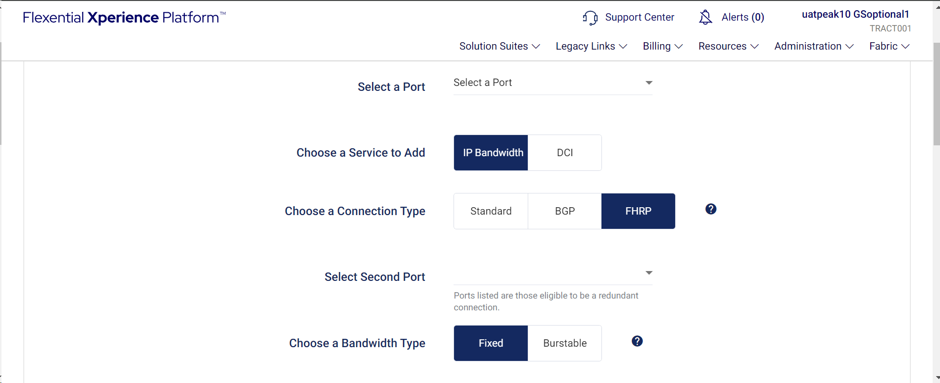

1. The **WAN Transit assignment** field will be a /29(IPv4) and /125 for the IPv6 subnet by default and cannot be changed.

## Add Service DCI

**Before you begin**: To add a DCI service, you are required to satisfy the following conditions:

1. You need to have a minimum of **two active** ports( A- Side and Z-Side) provisioned in FXP. See How to order a port.

2. Administrator or Tech Plus users can Add a Service for your port.

3. To understand the technical terms used in the Add Service Page, see Technical Terms used in Fabric.

To add services of the DCI, do the following:

|  |  |
| --- | --- |
| 1. Choose one of your subscribed ports on the **Select a Port** drop-down menu. | Badge 1 with solid fill |
| 1. In the **Choose a Service to Add** section, select the DCI. **DCI**: Data Center Interconnect (DCI) is a Flexential private point-to-point layer two virtual circuit service. | Badge with solid fill |
| 1. Select the Receiving Fabric Port. The **Receiving Flexential Fabric Port (Z Side)** is equal from a technical perspective but has no associated billing.   **Note**: As a point-to-point service, DCI does not technically have a concept of redundant hand-off. To achieve this redundancy, you can order an additional DCI service. This approach is advised to deploy a secondary DCI on a secondary physical port. | Badge 3 with solid fill |
| 1. On the **Choose a Bandwidth Type**, select Fixed or Burstable.  * Fixed bandwidth does not allow bandwidth consumption beyond the committed bandwidth value. * Burstable bandwidth allows for overages using the 95% calculation.   Please refer to the Platform Wide Attributes & Concepts section for further details. | Badge 4 with solid fill |
| 1. In the **Choose a Commit** section, you can enter or choose the value based on your bandwidth selection.      * **Fixed bandwidth Type**: Select the Commit Value from the drop-down menu. The values are available from 1000 Mbps to 50,000 Mbps.    * **Burstable bandwidth Type**: Enter your Commit value. The acceptable value is between 10 and 10,000.   **Note:** In this case commit range,10,000 is not the standard; it will depend on what is specified by the port, e.g:  uesw501.CLT04-10G-PID850999, the 10G equals the size but this can vary up to 50G(50,000)Mbps. | Fixed:  Badge 5 with solid fill  Burstable:  Badge 5 with solid fill |
| 1. Select the rate limit value in the **Choose rate limit** section based on your bandwidth selection.  * **Fixed bandwidth type**: The rate limit will equal the Committed value. This section is disabled for the selection of fixed bandwidth type.      * **Burstable bandwidth type:**  Choose the rate limit from the drop-down menu. The available values are between 1000 Mbps and 10,000 Mbps.   **Note:** When you choose a Commit value, the Rate Limit value gets dynamically populated with the next highest value allowed, greater than the Commit. | Burstable:  Badge 6 with solid fill |
| 1. On the **Pick a Term** section, select any one of the following:    * Match to Port Contract    * Month to Month | Badge 7 with solid fill |
| 1. Enter the number between 2 and 4094 on the **Enter your VLAN** field. | Badge 8 with solid fill |
| 1. On the **Service Description**, you can add a friendly name.   **Note:** This is an optional field for user naming. This is recommended for teams that may have many people using the fabric and want an easy way to communicate with each other about what each VC is doing within your business. | Badge 9 with solid fill |
| 1. After you enter all the mandatory fields, click the **Review & Submit Order** button to navigate to Step 2: Review & Submit Order. |  |

## Step 2: Review & Submit Order

In Step2, you can review the order and view the following:

|  |
| --- |
| * You can validate your selection in Step 1: General Info. * Preview the cost before ordering the services to ensure that your order is accurate and that you agree with the pricing/T&C.   After your review,  Click the check box at I agree to the pricing, Terms & Conditions, and then click **Order**. |

The Setup Price Total (NRC) details appear to the users in the following procedures:

* **New Order:** The Setup Price Total (NRC) is displayed by default when creating a new Fabric order, even if no IP blocks are added to the Order.
* **Edit Order Additional IPs:** When a user edits an existing Fabric order and adds an IP block, the NRC (Setup Price) details appear to the user.
* **No NRC details:** When a user edits an existing Fabric order, unless additional IP blocks are added, the Setup Price Total (NRC) details do not appear to the user.

## Step 3: Order Confirmation

In Step 3, your order confirmation details are displayed. You can download the order details.

## Download Receipt

The Download Receipt button is in the Add Service process's Step 3: Order Confirmation section.

Click the **Download Receipt** button to download the order and pricing details in PDF format.

# Match to Port Contract Option for Fabric Products

You can add a new service or convert an existing service with your existing port contract, provided you meet the eligibility criteria. This process ensures a smooth transition and contract alignment within the Fabric product suite.

* **If you have 45 days or more remaining on your port contract:**  
  When you try to purchase a new service or convert from Month-to-Month (M2M) to a termed contract, you will see the **"Match to Port Contract"** option in the commit drop-down menu.
* **If you have less than 45 days remaining on your port contract:**  
  You cannot purchase a new termed product. You are also not allowed to convert from M2M to termed contracts.

How it Works:

1. **Initiate a new purchase or conversion:**  
   Start the process for buying a new Fabric product or converting your existing contract from M2M to termed.
2. **Check for contract match option:**  
   If you meet the eligibility criteria (45 days or more remaining on your port contract), you will find and can select the **Match to Port Contract** option in the commit period selection.
3. **If you do not meet the criteria:**  
   The system will prevent you from selecting or accessing termed products and from converting M2M contracts to termed.

# Fabric Renewal: Commit Value Reduction and Service Cancellation

1. **Lower Your Commit Value**

* **When your Fabric service has 90–31 days left before it expires,** you can reduce your commit value.
* Go to **Edit Service.** The commit drop-down will show lower options than your current commit value.
* This option is available for all Fabric products, including IP Bandwidth, DCI, Mesh, and Virtual Connection.

**Example:**  
If you have a Fabric order with a commit value of 3000 and the service expires in 60 days, you can lower your commit by selecting a smaller amount from the commit drop-down.

**2. Cancel Without Early Termination Fee (ETF)**

* If your contract ends in 90–31 days (or before your renewal contract is ready for signature), you can cancel your term service without paying an ETF.
* If you try to cancel **91+ days before renewal,** you will pay an ETF as per the standard rules.

**3. Restrictions Near Contract End**

* When your contract has **30 days or less left, or after the renewal contract is out for signature,** you cannot edit or cancel the service.
* The **Edit (✏️)** and **Cancel (🗑️)** icons will be greyed out and unavailable.
* After you renew your contract, you will regain the ability to edit or cancel your service.

If you need more help, please reach out to our support team.

# Edit Service

Users with Administrator and Tech Plus roles can edit the services.

To edit the service, do the following:

1. Under the Your Ports & Services section, click **View Services Details**.
2. The **Service Details** section opens for your port.

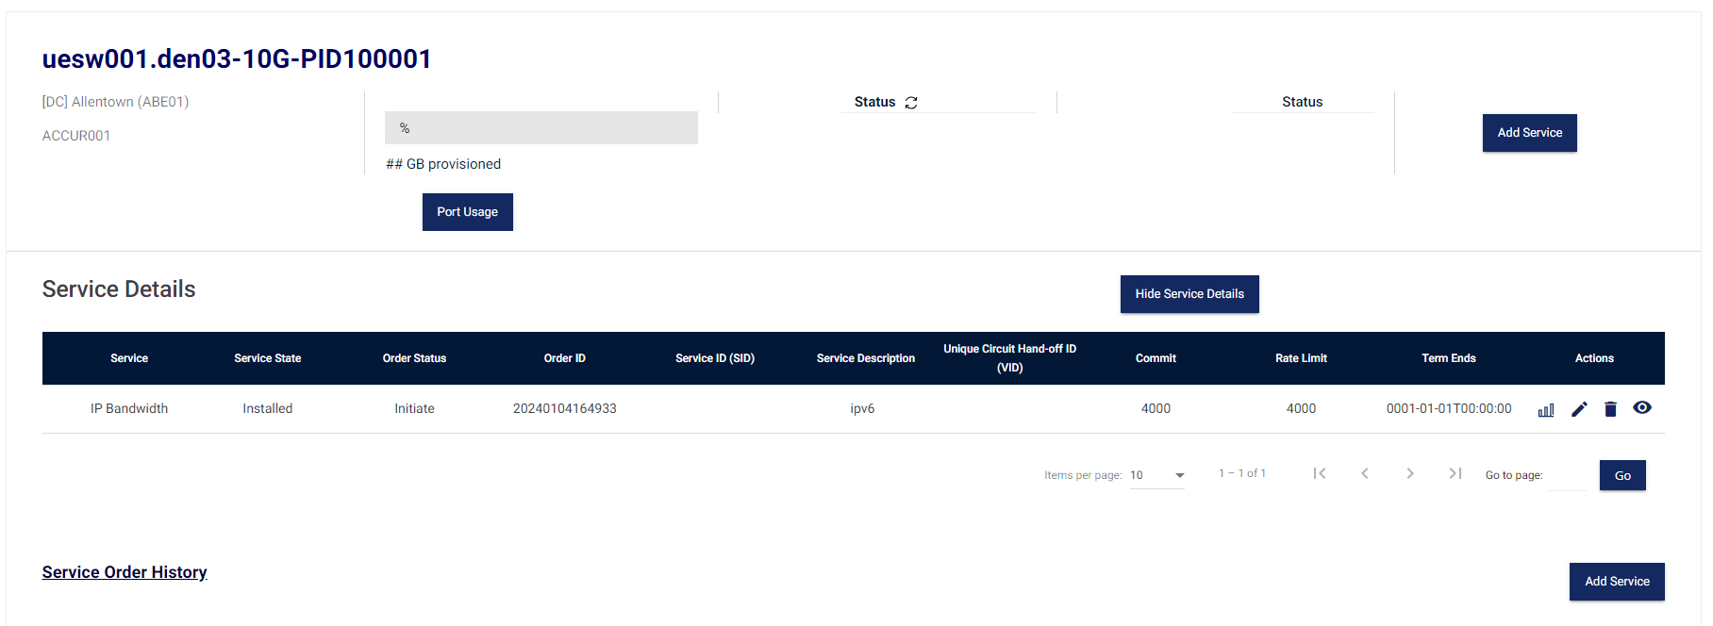

1. Choose the services that you wish to edit.
2. Under the Actions column, Click the pencil icon to edit the services.

# Edit Service- IP Bandwidth- Standard/ FHRP

After you open the edit service page and do the required modifications, the following items are editable in the IP Bandwidth edit service:

1. If required, change the Bandwidth Type
2. If required, change the Commit Value and Rate limit.

**Note**:  **"**Match to Port Contract" users can only increase their commit value, not decrease it.   
However, month-to-month users can decrease or increase the commit value.

* 1. For **Fixed Bandwidth** type
     1. Change the Commit value. On the **Choose a Commit** field, change the value.
     2. The Rate value field is non-editable.
  2. For **Burstable Bandwidth** type
     1. Change the Commit value. On the **Choose a Commit** field, change the value. The changes in the Commit value enable the rate limit drop-down selection.
     2. Choose a rate limit that is more than the committed value. The maximum rate limit value is 10,000 Mbps.

1. You can add additional LAN or Routed Network blocks of IPv4.

On the Additional LAN or Routed Network Block section, click **Add** to add an IPv4.

* 1. Select the IP assignment from the drop-down list. You can increase the IP assignment, but you cannot delete or reduce the existing IP assignment.

1. You can add Additional LAN or Routed Network IPv6 Blocks.

On the Additional LAN or Routed Network IPv6 Blocks section, click **Add.**

* 1. Select the IP assignment from the drop-down list. You can increase the IP assignment, but you cannot delete or reduce the existing IP assignment.  
     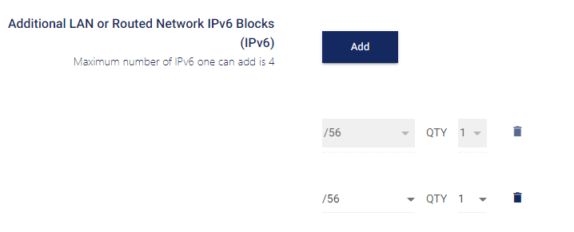

1. If required, if you wish to change the IP address of your existing IPs, do the following:
   1. On the **List your IPs** section, based on your previous selection, modify IPv4 and IPv6 details.

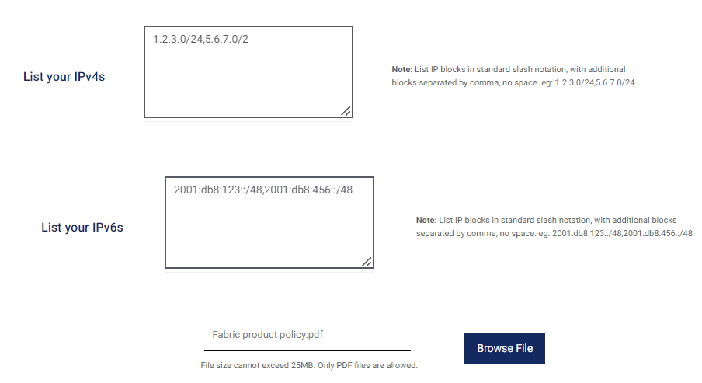

**Note**: Please input your IPs in the adjacent field. Your input will supersede the previous IP list, so you must provide the list of all your IPs used on this service. An LOA document should also reflect the exact IP blocks permitted on this Flexential service.

* 1. If required, upload the support document. If you have multiple support documents, merge the file into a single PDF file.

Click **Browse File** to upload the document.

1. If required, you can modify the **Service Description**.
2. Click **Review & Submit the Order**.
3. On Step 2: Review & Submit page, validate your modification, and preview your billing details.
4. Select the checkbox for the term and condition.
5. Click **Submit**.
6. Confirm the change on the Order Confirmation page; the order number displays additional order summary and pricing details.

## Edit Service – DCI

After you navigate the edit service page and do the required modifications, the following items are editable in the DCI edit service:

1. If required, change the Commit Value and Rate limit.

**Note**:  **"**Match to Port Contract" users can only increase their commit value, not decrease it.   
However, month-to-month users can decrease or increase the commit value.

* 1. For **Fixed Bandwidth** type
     1. Change the Commit value. On the **Choose a Commit** field, change the value.
     2. The Rate value field is non-editable.
  2. For **Burstable Bandwidth** type
     1. Change the Commit value. On the **Choose a Commit** field, change the value. The changes in the Commit value enable the rate limit drop-down selection.
     2. Choose a rate limit that is more than the committed value. The maximum rate limit value is 10,000 Mbps.

1. If required, you can modify the **Service Description**.
2. Click **Review & Submit the Order**.
3. On Step 2: Review & Submit page, validate your modification, and preview your billing details.
4. Select the checkbox for the term and condition.
5. Click **Submit**.
6. Confirm the change on the Order Confirmation page. The order displays additional order summary and pricing details.

# Delete the IP Bandwidth Service (All Connection Types) and DCI

Users with Administrator and Tech Plus roles can delete the services. The delete button gets enabled only after the order state becomes "Delivered".

To delete the Services, do the following:

1. Under the Your Ports & Services section, click **View Services Details**.

1. The Service Details section opens for your port.

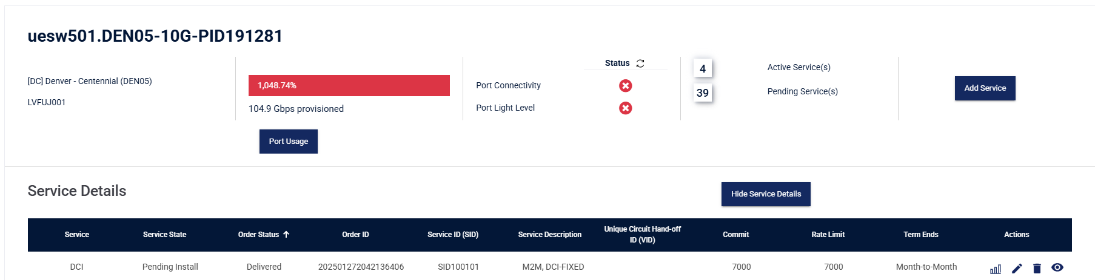

1. Choose the services that you wish to delete.
2. Under the Actions column, click the trash icon to delete the services.
3. Clicking on the trash can icon will give you a confirmation window and confirmation of any ETF(Early Termination fees), if applicable.
4. Click **Yes, Terminate** to delete the service.

# Need Help?

For questions or need additional assistance, please contact Flexential Service Support by opening a new Support Case in FXP via phone at (888) 552-3539 or via email at [support@flexential.com](mailto:support@flexential.com).

# Appendix – A: Advanced Concepts & Technical Insights

### Bandwidth Partitioning & Allocation

Properly allocating bandwidth to multiple services (IP Transit, DCI( Data Center Interconnection) on a single physical interface can be a new reality for many customers. Both rate limits and fixed circuits are specific bandwidth controls that can be implemented to ensure bandwidth for critical workloads is always available. It does not conflict with other services sharing the same interface. To ensure proper partitioning of the 10G interface, fixed circuits can be deployed for non-critical workloads or backup circuits that do not need the burstable capacity to satisfy traffic demand. For production workloads, burstable circuits can be deployed to ensure high-demand traffic spikes can be met with optimal connecting without users experiencing latency or packet loss. Rate limits could also be implemented on this burstable circuit to ensure a certain demand level of traffic is met by a specified upper limit, with overage charges past this amount being unacceptable from a financial perspective.

Please see below for an example highlighting the allocation of a Flexential Fabric physical interface into multiple services, resulting in a fully utilized 10 Gbps port with multiple services supporting production and backup workloads.

Aggregating IP transit and DCI services on a single physical interface can concern customers who are architecting fully fault-tolerant solutions. Flexential Fabric interfaces do not have to be partitioned into multiple virtual segments. This is up to the user's discretion, as workloads, services, and interconnection products can all reside on separate physical ports if desired.

### IPv4 vs IPv6

Internet Protocol (IP) is a defined set of rules that helps route data packets over the internet so traffic can arrive at its proper destination. There are two versions of IP: version 4, which is older, and version 6, which is newer. IPv4 is still the most common, using a 32-bit address yielding over 4 billion unique address combinations. IPv6 was developed to solve the inevitable exhaustion of IP addresses in the traditional IPv4 format. The newer version uses a 128-bit address, yielding exponentially (literally 2^128) an infinite number of addresses. The notations of each address are different. Please see below:

* IPv4: 248.76.225.197
* IPv6: 4209:eb90:80c1:4c40:e475:7c9b:aa78:4767

While less than 1% of networks use IPv6, it is more advanced than IPv4. It has better features like more efficient routing, bigger payloads, and simplified header formats. IP bandwidth supports IPv4 and IPv6 addressing, and users should select which version they are most comfortable with on their network. Please confirm the compatibility of running one address version over the other in your network, and remember that dual-stack is the best for having both IPv4 and IPv6 enabled.

## SLA (Service Level Agreement)

Services on single interfaces are subjected to Flexential standard 99.99% uptime SLA. Services delivered on redundant interfaces are permitted a 100% uptime SLA. Please consult your MSA for exact SLA language, terms, and conditions.

## Overages and 95th Percentile Calculations

For IP Bandwidth or IP Transit services, Flexential polls interface on a 5-minute basis, looking at ingress and egress utilization. At the end of the month, Flexential uses a standard 95th percentile function to calculate a 95th percentile value for both ingress and egress. The larger two values are selected and held against the user's committed bandwidth policy. The overage value (if any) is billed to the user at the existing contracted rate. Flexential does not apply an overage penalty, rate, or value.

For DCI, Interconnection Mesh, or other forms of 'Transport' services, Flexential performs the same process above but only accounts for the ingress 95th percentile value. By excluding egress, users are not at risk of getting overage bills for the same traffic across two interfaces.

### WAN Transit Assignment

The WAN Transit assignment connects the Provider Edge (PE) to the Customer Edge (CE) or Customer Provided Equipment (CPE). This block is typically small and not intended to provide IPs to actual hosts or specific services. Flexential, by default, provides a /31 to conserve IP assignments, but a /30 is also available. Some older equipment, specifically running older firmware, may not support a /31 assignment.

In a /31 assignment, the first usable IP address is assigned to Flexential and the second useable address is assigned to the customer (there is no network or broadcast address in a /31 as it is only for point-to-point connections). In a /30 WAN assignment, the first IP address is the network IP, the first is Flexenital, and the second is the customer. The final IP address is reserved for the broadcast address.

The default WAN IP address block assigned for FHRP configurations is a /29. In a /29 WAN assignment, the first IP address is the network IP, the first usable address is the virtual IP (VIP), the next two usable addresses in the block are assigned to Flexential's primary and redundant routers, the remaining usable addresses are assigned to the customer, and the final IP address is reserved for the broadcast address.

## Appendix – B: Additional IP Bandwidth Connection Configurations

## Add Service: IP Bandwidth BGP Configuration

**IP Bandwidth - BGP - Border Gateway Protocol (BGP)** uses advanced dynamic routing for routing between autonomous systems (AS) instead of static routing on Flexential Internet service. Advanced networking skill is required as BGP requires additional information below for setup and configuration:

* **Autonomous System Number (ASN)** – a unique identifier that is globally available and allows its autonomous system to exchange routing information with other systems. The customer can provide this, or you can use Flexential's private ASN.
* **Desired BGP Advertisements** – There are many options you can use to advertise address space:
  + **Default Route**
  + **Full BGP Routing Table**
  + **Default Route + Full BGP Routing Table**
  + **Partial Routing Table**
  + **Default Route + Partial Routing Table**

Please reference the following architecture for the BGP configuration below:



**Follow the Steps 1 through 14 on the** **Add Service: IP Bandwidth - Standard (Static) Connection****. Steps 1 through 14 for adding IP Bandwidth Service are the same for the BGP connection type. Please use the below section for the additional steps associated with adding a BGP connection type:**

Note: The section below is only applicable to BGP connection types.

B

A

1. On the Customer ASN Drop-down menu, select any one of the following options:  
   A screenshot of a computer

   Description automatically generated

|  |  |
| --- | --- |
| * + - **Assign new private ASN**: Select this option to get a new private ASN from Flexential. |  |
| * + - **Existing private ASN:** If you select Existing private ASN from Flexential, select your ASN from the drop-down menu. |  |
| * + - **Enter your own ASN**   If you have your own ASN number, then enter your ASN value.  The acceptable value is between 1- 64495 or 65536-4199999999 |  |
| B. On the **Desired Flexential Advertisements** drop-down menu, select any one of the following options:   * + - Default     - Full     - Partial     - Full+ Partial     - Partial + Default |  |

15. After you enter all the mandatory fields, click the **Review & Submit Order** button to navigate to Step 2: Review & Submit Order.

## Edit Service- IP Bandwidth- BGP

After you open the edit service page and do the required modifications, the following items are editable in the IP Bandwidth edit service:

The steps below apply only to the BGP Connection type. Please follow steps 1 through 4 in the "Edit Service – IP Bandwidth Section – Standard" section for editing bandwidth and IP address blocks.

* 1. If required, change the value from the desired Flexential Advertisements drop-down list. The available options are as follows:
     + 1. Default
       2. Full
       3. Full + Default
       4. Partial
       5. Partial + Default
  2. Change the value from the Desired Customer Advertisements drop-down list.
  3. If you select **Advertise my own IPs**, then do the following:
     + 1. Enter your IPs in the Add your IPs field.

**Note:**   
Please enter your prefixes in a separate list in slash notation (e.g., /22).  
The "Are you bringing your IPs format" field above validates your advertised IPs. Flexential must validate their registry and ownership before advertising.

* + - 1. If you select the Advertise Flexential provided IPs. Then, Flexential will provide the IPs.

Follow steps 5-10 in the "Edit Service – IP Bandwidth Section – Standard" to complete the process.

# Glossary

|  |  |
| --- | --- |
| Technical Terms | Definition |
| Bandwidth | Bandwidth refers to data transfer rates and is typically measured by the amount of data carried from one point to another in a given period. |
| Border Gateway Protocol (BGP) | A BGP is a standardized exterior gateway protocol that exchanges routing information between autonomous systems in a network. |
| Burstability | Burstability is the ability to utilize higher bandwidth for increased network speeds, allowing you to transfer large files without interruption. |
| Layer 1 | Layer 1 is the physical layer in a network consisting of fiber, cables, and connections. In the Layer 1 environment, data is transmitted and transported to virtual networks. |
| Layer 2 | Layer 2 is the data link layer that transfers data to other network nodes in a wide area network (WAN) or between nodes on a local area network (LAN). |
| Layer 3 | Layer 3 is the network layer that manages packet forwarding, which includes routing through intermediate routers and recognizing and forwarding data for the local host domain. |
| Megabit | A megabit is a unit of information the size of one million bits. It is frequently used to measure the data transferred between two points within one second. |
| Megabyte | A megabyte is a unit of information the size of one million bytes. A meg is considered a small measurement for data information. |
| Point-to-Point | Data transmissions between a single transmitter and a single receiver occur in a point-to-point environment. Point-to-point communications can be wired or wireless and involve communication between two parties. |
| Point-to-Multipoint | Point-to-multipoint involves data transmissions between one sender and multiple receivers. Point-to-multipoint communications can be wired or wireless and involve communication between various parties. |
| Redundancy | Redundancy safeguards data communications using protected fiber routes with diverse paths. Networks with redundancy have an added layer of reliability, translating to minimal disruptions in service. With redundant pathways, a network has to fail in multiple environments to cause an outage. |
| Routed Network | The routed network infrastructure distributes data throughout all routers between different networks. Routed networks operate at Layer 3. |
| Scalability | Scalability refers to a network's capacity for growth and future expansion. Within a scalable network, customers can expand and upgrade their service usage through their current network. |
| VLAN (Virtual Local Area Network) | A VLAN enables network operators to partition their networks to meet their systems' security and functionality requirements without installing new fiber in the current network infrastructure. |
| WAN (Wide Area Network) | A wide area network expands across a large geographical area, connecting multiple smaller networks, including local area networks (LANs). |

Roles and Responsibilities Matrix

The Flexential Fabric service has the following Responsibilities, as denoted with the letter of “R”:

|  |  |  |  |
| --- | --- | --- | --- |
| Category | Responsibility | Flexential | Customer |
| Service Design | Capacity – Size physical interface correctly, size bandwidth policy correctly per service |  | R |
| Service Design | Failover, Redundancy, HA Planning – allocate redundant port, failing over to another service, etc. |  | R |
| Implementation | Deliver cross connect and physical port | R |  |
| Implementation | Portal access established | R | R |
| Service Transition | Confirm L1-L2 link layer between customer gear (CPE) and Flexential gear (PE) | R | R |
| Steady State Operations | Order and manage Flexential services on Fabric |  | R |
| Steady State Operations | Maintain all services regardless of underlying physical outages and capacity planning | R |  |
| Steady State Operations | On-going capacity planning to continually ensure ports and policies are sized correctly to avoid saturation events |  | R |